The Battle of Neighborhooods W2 Report

1. INTRODUCTION:

Imagine that we want to go to New York for our holidays and we want to know how to choose an airbnb to stay a few days. Well in my project, I will compare the airbnbs in New York City and determine how similar or dissimilar they are based in pricing and neighbour criminality because we also want a peaceful stay. For that i have researched for 2 databases. one with the prices and another with the criminality. The objective is to merge them and fit a model for this resolution. Obviously the travel market would be very interested in this type of data, also the people who travels wich is almost everyone and real estate investors who want to profit their resources.

1. DATA:

Both datasets are public and anyone can Access them by loging in the hosting pages they are associated to:

Airbnb csv:

<https://www.kaggle.com/dgomonov/new-york-city-airbnb-open-data/>

Criminality csv:

<https://data.world/data-society/nyc-crime-data>

1. METHODOLOGY:

I’ve trained a k-model with a k=10 to approximate to my desired request. To do that i’ve fitted the model with a dataset resulted from the normalization to 1 of the prices and the criminality.

1. RESULTS:

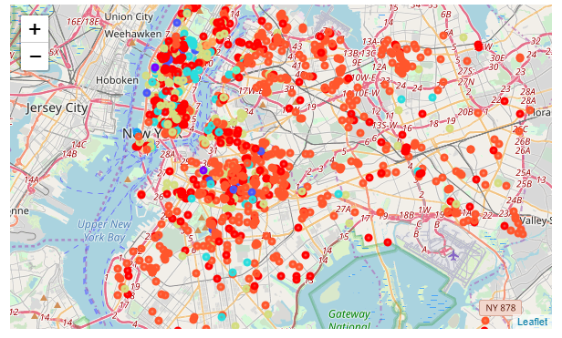

As we can see there is a Little bit of chaos in the picture. It is shown that Manhattan (top-left) is the best option to choose because trained with prices and criminality it has the best options (best to worse ->Purple -- Blue -- Green -- Orange -- Red)

1. DISCUSSION:

Not only Manhattan is a Good choice but, there are several places near the bridges out of Manhattan that present a realy Good quality too. Also there are some Good spots around Brooklyn. If i had to choose, maybe those places would be my choice.

1. CONCLUSSION:

The initial needs are now satisfied. We wanted to sort and cluster the better choices for our trip and it concluded that Manhattan is the best option. Also Brooklyn could be considered.